Algebra 1 Review for Final Spring 2016

Name:________________________________________________________Score:______/______Period: _______

**Show all your work on the test and write the answers on the answer sheet**. Good Luck!

1.) Give an example of an equation in slope intercept form.

2.) Give an example of an equation in standard form.

3.) Write an algebraic expression for *7 times x squared minus the product of 4 and 7.*

4.) Write a verbal expression for 3n – 9/2t.

5.) Evaluate -2 + 6 ∙ 5 – 1

6.) Evaluate -6(9– 12) + 32 ÷ 4

7.) Evaluate 6k + m if k = 2 and m = 6.

8.) Evaluate 6 + 4 - 7 - (- 2)

9.) Evaluate 2 ($4^{2}+3$) – 22 ÷ 11

10.) Evaluate 5 $\frac{5}{6}+ 6+\frac{1}{6}$

11.) Evaluate │ 3b – 5 │ + 6 if b = -3

12.) Solve $\frac{3}{5}$ x = $\frac{12}{15}$

13.) Solve -3t + 8 = 5

14.) Solve $\frac{k}{5}$- 3= - 19

15.) Solve │ c – 6 │ = 22

(Hint: 2 cases)

16.) Solve the proportion $\frac{5}{12}=\frac{x}{36}$

17.) Solve 2(t + 2) = 5t – 7

18.) What is the **X-INTERCEPT** of y = -2x – 6

19.) What is the **Y-INTERCEPT** of y=-3x – 3

**For question 20-23, find the slope of each line described.**

20.) the line through (1, -4) and (-2, 4)

21.) a vertical line

22.) a horizontal line

23.) What is the slope and the y-intercept of this linear equation **y = 3x + 1**

**For problems: 24 –26, Write the equation in slope intercept form:**

24.) Slope =1/3 and the point (3, -1)

25.) 2x-4y=12

26.) through the points (-1,2) and (1,-3)

**Graph the following and state the slope and the y-intercept:**

27.) y=-3/4x+1

Slope =__________ Y-intercept=____________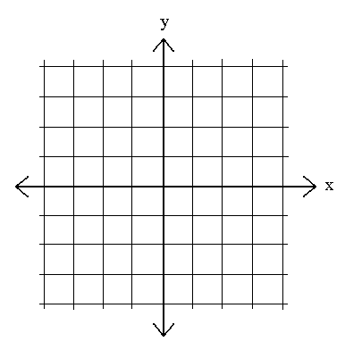

28.) y = 2x -2

Slope=__________ Y-Intercept=___________

1. With the points A(0,0) B(0,9) and C (8,0), draw the triangle and find the length of the hypotenuse using Pythagorean theorem, then find the distance of **each side** using the distance formula, and find the midpoint of **all three sides** using the midpoint formula. ( You may use the formulas or a graph to answer)

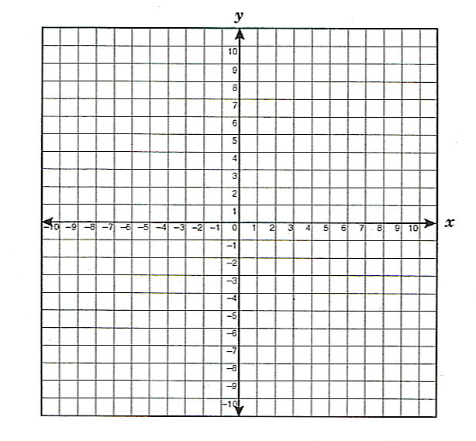

Distance AB=_______ Midpoint AB=(___,___)

Distance BC=_______ Midpoint BC=(___,___)

Distance CA=_______ Midpoint CA=(___,___)

**Simplify the radical**

30) 31) 32) 4 33) $\sqrt{4}$

**Perform the following operations and simplify all radicals**

34)  35)  36)  37) 

38)  39)  40)  41) 

42)  43)  44) 

**Classify each as M (monomial), B (binomial), T (trinomial), P (polynomial), or C (constant). Then identify the leading coefficient, leading term, degree, and constant.**

45).______15 46).______  47).______ 

Leading Coefficient=_______ Leading Coefficient=_______ Leading Coefficient=_______

Leading Term=________ Leading Term=________ Leading Term=________

Degree=________ Degree=________ Degree=________

Constant=__________ Constant=__________ Constant=__________

**Operations with monomial.**

**48**). 5xyz (5xz) 49). -3(6yz) 50). (  )

51). 3xy+ 6xy- xy – 10y +59y 52) (

53) (2x - 2)(6x + 3) 54) (2x +5 )²

55) **Scientific Notation, Write in scientific notation**  300,000,000,000

56**) Scientific Notation, Write in standard form.** 9.203 x ${10}^{-9}$

**Factor each equation (just factor, don’t solve).**

57) 3 – 15 58) 12 $x^{2}u+3x^{2}b+28yu+7yb$

**Solve the equation, by factoring. (hint: factor and then set each piece = to 0 and solve)**

59) y = 2x2 + 6x 60) y= x2 + 8x - 20 61

62) 63) y = - 64) y = - $12x^{2}+26x+56$

**Solve by Pythagorean Theorem.**

65) y = 66) y=18 $x^{2}+3x-36$

**Graph the Quadratic equation and label the axis of symmetry, vertex, and zeros.**

67) y = - 68) y= 2

