3-D “Scale Model” Project
Geometry 2018
100 points
10% off per day if turned in late
Due Date: January 29^{th,} 2018 by the end of the day.

Your job is to choose a three-dimensional object (Must be a Rectangular Prism).with a logo or some type of graphic design (candy box, cereal box, cracker box, etc…), and enlarge OR reduce it by a scale factor of 1:3, 1:4, 1:5, 1:6 or 1:1/3 , 1: 1/4, 1: 1/5, 1: 1/6 (pick one). Every aspect of the new item including logos, side length, writing or any other key characteristic of the original item must follow the same ratio of enlargement.

Materials:
- Original object to be enlarged/reduced
- Poster paper or thicker paper so that the resized object won’t be too weak or any other material that would be useful like wood, tape, glue, etc…
- Pencil
- Ruler w/ cm measurement
- Coloring utensils

Procedure:
- This project must be done individually.
- Choose a three-dimensional rectangular prism object to resize
- Use a formula from the formula sheet for the figure that matches your original object, and measure the required dimensions using centimeters.
- Use the measurement and scale factor to calculate the dimensions of your enlargement/reduction.
- Construct the enlargement/reduction according to the dimensions you determined. Make sure to preserve the proportions of all logos and writing so that the enlargement looks exactly like the original object.
- Complete all parts of the project packet.
- Review the grading rubric to ensure that your project meets all the required components

Turn in:
- The original object or photo
- Resized object
- Project packet- one per object
- Any extra work done for calculations

Name:________________________

Enlargement ratio chosen (circle one): 1:3 1:4 1:5 1:6

…or reduction ratio chosen: 1:1/3 1:1/4 1: 1/5 1:1/6

Formula Sheet
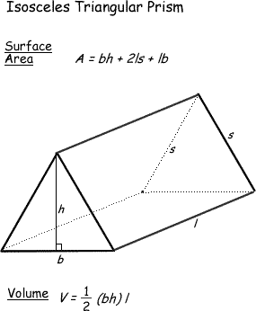 | 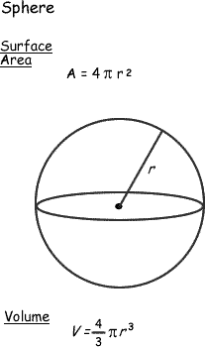
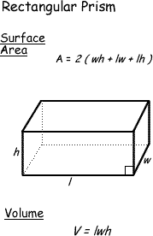 | 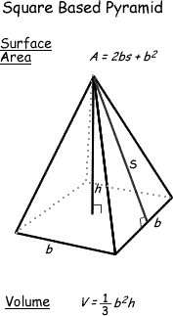
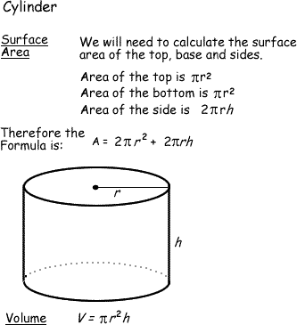 | 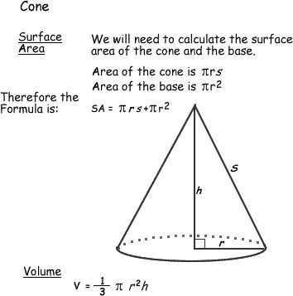

Answer the following questions regarding your project. Remember to use the formulas provided in the packet. Please show your work in boxes provided. Each question is worth 5 points.

- Draw the front, side, and top views for your original and resized item. Include all of your measurements.

Give measurements for the length and width of all three side views

You do not need to draw all details on box, just major parts for sizing.

Original:
Front: Side: Top:

Resized:
Front: Side: Top:
2. Calculate the surface area and volume for your original item. Show work in the boxes!

Original Surface Area:

Original Volume:
3. Calculate the surface area and volume for your resized item. Show work in the boxes!

Resized Surface Area:

Resized Volume:

4. Select a linear measurement from your original item (side length, height, etc.) and find the following ratios below. Be sure to reduce all ratios.

a. Linear Measurement from Original =
Linear Measurement from Resized Item
What is the relationship between this ratio and the original scale factor?

b. Surface Area of Original =
Surface Area of Resized Item
What happened mathematically between the scale factor and the surface area ratio?

c. Volume of Original =
Volume of Resized Item

What happened mathematically between the scale factor and the volume ratio?

5. Answer the following questions using complete sentences.

a. What did you learn about ratios and scale factors in completing this project?

b. In what careers do you think this process would be used? Be specific.

c. Explain any challenges you encountered in completing this project.

“Scale Model” Grading Rubric
The following rubric will be used to grade your project. Please reference it while you are doing your project to ensure that you obtain the highest score possible. You must do a self-evaluation (please give a score and comment) and overall comments on how the project went.

Criteria Point Value |  |  |  |  | Self -Evaluation Score:
Mathematical Similarity to the Original Item  ➢ How accurate are the measurements of your resized item? Is your enlargement/reduction built to scale? | 50 points  Item is built to scale and all dimensions are accurate | 40 points  Item has some mistakes/ some calculation errors were made | 30 points  Item has many errors and is not built to scale | 0 points  Not completed/ No effort put in
Mathematical Calculations for the Both Items  ➢ Have you calculated the surface area and volume of both figures and answered all of the accompanying questions. See questions for point breakdown. Points are awarded for effort and accuracy, so make sure to show all work for partial credit. | 25 points  All formulas are correctly used and computations are correct | 20 points  Correct formulas are used and some computational errors | 15 points  Correct formulas are used with many computational errors or wrong formulas are used. | 0 points  Not completed/ No effort put in
Object’s Complexity/Student Effort/Visual Likeness  ➢ Just by looking at your resized item, does it look like a bigger/smaller version of the original?  ➢ Are your logos, any writing, or identifying characteristic in the correct proportion?  ➢ The artistry on the enlargement/reduction is neat, clean and care is taken in its construction.  ➢ Does this look like something that took 2 hours or less? Or was great effort taken to perfect it? | 25 points Student’s item is neat and nicely put together. Great care has been taken in the decoration of the item | 20 points  Student has put some effort in, but there are parts of the item that are put together with out care. The logos are not enlarged or colored | 15 points Student’s item is not neatly put together and minimal care seems to have been put into doing this project. | 0 Points Not completed/ No effort put in

Grade: Self-Evaluation Grade:_________________

Teacher Comments: Defend the score you gave yourself (here):

