Unit 3 Review
Algebra 1 – Linear Functions
Name:____________________
Period:______ Score:______/______
Graph each equation:
- y = -2x -3 2) y = 3/2 x 3) x= -2 4) 2x – 3y = -6
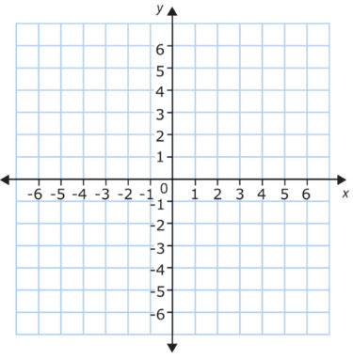
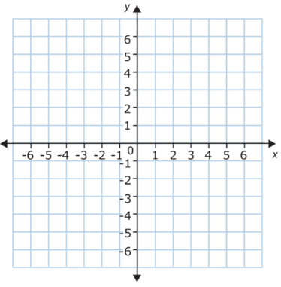

Evaluate the Intercepts and slope of the following equations:
5) y = -1/2 x + 6 6) 4x – 6 y = 12 7) Y = 5
Y-intercept :_______ Y-intercept :_______ Y-intercept :_______
X- intercept:_______ X- intercept:_______ X- intercept:_______
Slope :_______ Slope :_______ Slope :_______

Evaluate the roots/zeros/solutions/x-intercepts to the following:
8) y = 2x – 8 9) 2x –3y = 6 9) 6x – 3 = y

X=_____ X=_____ X=______
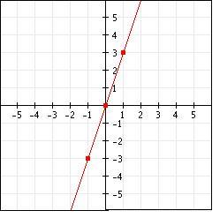
Evaluate the slope:
10) Slope :______ 11) Slope=________ 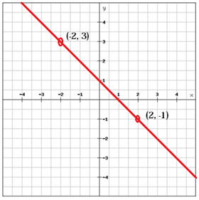

Identify the Slope, x-intercept and y-intercept of the following:
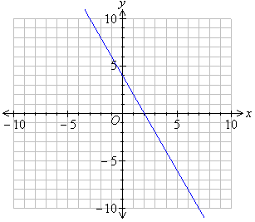
12) 13)
X | Y
-2 | 9
0 | 6
2 | 3
4 | 0

Y-intercept=_________
X-intercept=_________ Y-intercept=_________
Slope=_________ X-intercept=_________ Slope=_________

Calculate the slope of the line that passes through each pair of points.
14) (3, -2) (4, 8) 15) (-3, 9) (-3, 2)

Slope =________ Slope =_______

